EVENT MANAGEMENT: BUNJIL PLACE
OHS RISK ASSESSMENT PLAN 2023

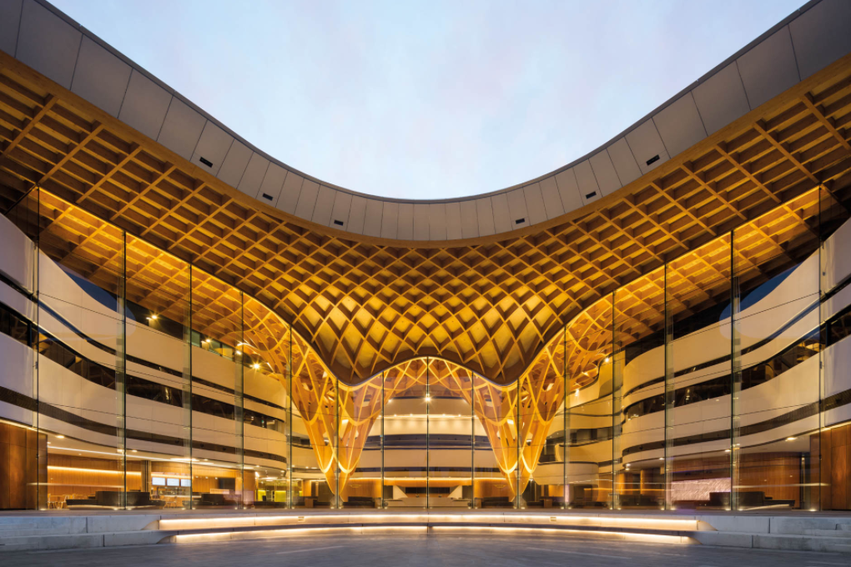
Implementing & Evaluating a Community Project
WHAT TO BRING TO THE BUNJIL PLACE EXCURSION:
□ Create a tick sheet with a list of everything that you and your team must do and information you MUST COLLECT while we are on EXCURSION.
□ Pack your phone & charger to access the pictures taken at the train station, Bunjil Place Library, back of stage, change rooms & the Food court
□ Pack your snacks/money if you have permission to purchase your lunch
□ Bring your laptop! A booklet will be provided for you.
□ You are to work in a team to complete the following OHS/Risk Assessment BUT your written tasks, need to be done individually. Additionally, your group needs to be approved by your teacher.
□ Ask for clarification for this assessment BEFORE you go on the excursion.

4C’s TIMELINE - KEY DATES AND TIMES
T2 Week 6  5/6 – 8/6 | Introduction: to the 2023 4C’s Showcase PP, available through the Curriculum resources in numerical order. | Students to start thinking about the tasks they hope to start working on, specifically the 4C’s logo and Posters (introduction to the competition) If students are preparing to go to Bunjil Place for the OH&S excursion. Permission slips need to be made available.
T2 Week 7  11/6 – 15/6 | Introduction: to the 2023 4C’s Showcase PP, available through the Curriculum resources in numerical order. | Engage in conversation regarding the negotiated curriculum. Teachers will discuss negotiables/non-negotiable and marking keys/matrix. Bunjil Place for the OH&S excursion - permission slips need to be submitted.
T2 Week 8  19/6 – 22/6 | Students to commence working on a list based on assigned tasks and choice. | Submit the list of tasks and negotiables/non-negotiable and marking keys/matrix. Bunjil Place for the OH&S excursion - permission slips need to be submitted.
T3 Week 1  10/7- 13/7 | Bunjil Place Excursion: June  Tues13th, Thurs 15th & Mon19th | Complete the questions and the booklet while at Bunjil Place.
T3 Week 2  17/7 – 20/7 | Bunjil Place Excursion: June  Tues13th, Thurs 15th & Mon19th | Complete the questions and the booklet while at Bunjil Place.  4C’s POSTERS & 4C’s LOGO  due at the end of this week
T3 Week 3  24/7– 27/7 | Student choice and agency – Work on the booklet provided. Complete any reflection tasks, group minute meetings add to, prepare template for final PP for presentation. Document weekly diary entry. | WINNERS ANNOUNCED AT THE END OF THE WEEK FOR CHOSEN 4C’s POSTERS & 4C’s LOGOS
T3 Week 4  31/7– 3/8 | Student choice and agency – Work on the booklet provided. Complete any reflection tasks, group minute meetings add to, prepare template for final PP for presentation. Document weekly diary entry | Permission slips to go to Bunjil Place if attending the performance dates
T3 Week 5  7/8 – 10/8 | Student choice and agency – Work on the booklet provided. Complete any reflection tasks, group minute meetings add to, prepare template for final PP for presentation. Document weekly diary entry | By the end of the week, you need to go through your personal timeline and ensure the tasks you aimed to complete have been submitted or close to completion.
T3 Week 6  14/8 – 17/8 | Student choice and agency – Work on the booklet provided. Complete any reflection tasks, group minute meetings add to, prepare template for final PP for presentation. Document weekly diary entry | By the end of the week, you need to go through your personal timeline and ensure the tasks you aimed to complete have been submitted or close to completion.
T3 Week 7  21/8– 24/8 | Student choice and agency – Work on the booklet provided. Complete any reflection tasks, group minute meetings add to, prepare template for final PP for presentation. Document weekly diary entry | Make sure your PP template has been completed and ready so you can submit your interviews and images collected on the performance day.
T3 Week 8  28/8 – 31/8 | MONDAY 28th August  4C’s Performance Night 1 | Input photos and interviews into PP and present to an audience & prepare to present your final PP.
T3 Week 9  4/9 – 7/9 | MONDAY 4th of September  4C’s Performance Night 2 | Input photos and interviews into PP and present to an audience – Final check and organize a time to present.
T3 Week 10  11/9 – 14/9 | MONDAY 11th of September  4C’s Performance Night 3 | Input photos and interviews into PP and present to an audience.

OHS RISK ASSESSMENT 2023
Why are we assessing the following areas?
One of the major tasks you need to complete is an OHS RISK ASSESSMENT for the 4C’s event. The places that have been chosen for you to write assessments for are the areas that will be used by our stakeholders and our guests.

1. NARRE WARREN TRAIN STATION: Our families, friends, and guests may need to access public transport on the 5th and 12th of September. We need to ensure that the Station Master is contacted prior to the event to notify them of the event taking place. There may be a large number of people accessing public transport in the evening, prior to the show. There may be a need for extra Protective Service Officers (PSO) from 5 pm till roughly 10:30 pm.
2. BUNJIL PLACE: The event is going to take place on the premises, so becoming familiar with all the spaces, rooms, and areas we will be accessing is vital. Knowing that there will be limited room available at Bunjil Place due to the Archibald exhibition is important. When accessing the spaces make sure you pay attention to how many people can fit in each of the spaces. You will need to assign the school groups rooms and relevant spaces based on the school’s needs and the number of students.
3. NARRE WARREN LIBRARY: This year, for the first time in 16 years, 4C’s is creating a space for students to be able to present their VET items. The main art forms we are going to display are; Fashion & Design, Carvings, and Visual Arts. This space has been opened up to include Community art to inspire our students and for our communities to share their creative abilities.
FOUNTAIN GATE FOOD COURT: The food court is going to be an area that will need to be used by schools to organise their lunch or dinner, before the 4C’s event. Some schools will provide their own meals, others will need to access these spaces. It will be our responsibility to ensure that the schools do not access the Food Court at the same time. How can we ensure that accessing the food court does not become an issue?

BUNJIL PLACE QUESTIONS TO COMPLETE AND RISK ASSESSMENT
- OHS requirements - RISK ASSESSMENT before the event:

- Who are the core teams that will make the event happen?

- Consider delivery, engagement, and room layout.

- Are there venue maps or links available at Bunjil Place?

- Take photos of the area for schools and organisers to use

- Annotate the photos that were taken on the day. Students need to have evidence of the plan to share with their group

Risk Assessment and Risk Management

Just a thought - What needs to be done for your school this term:

- Student permission slips to Bunjil Place (before and after the event)
- Consent forms signed for photos and images to be taken or shared on social media.
- Consent for student work to be published online (Bunjil Place website)

Complete the risk assessment table then each of the questions:

You need to identify a minimum
of 3-5 hazards.

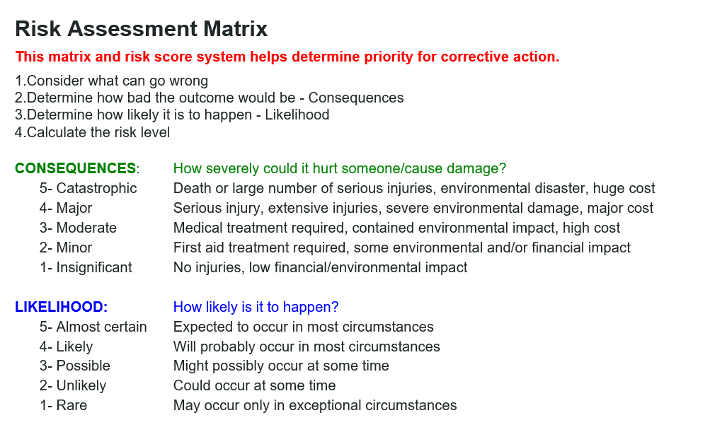

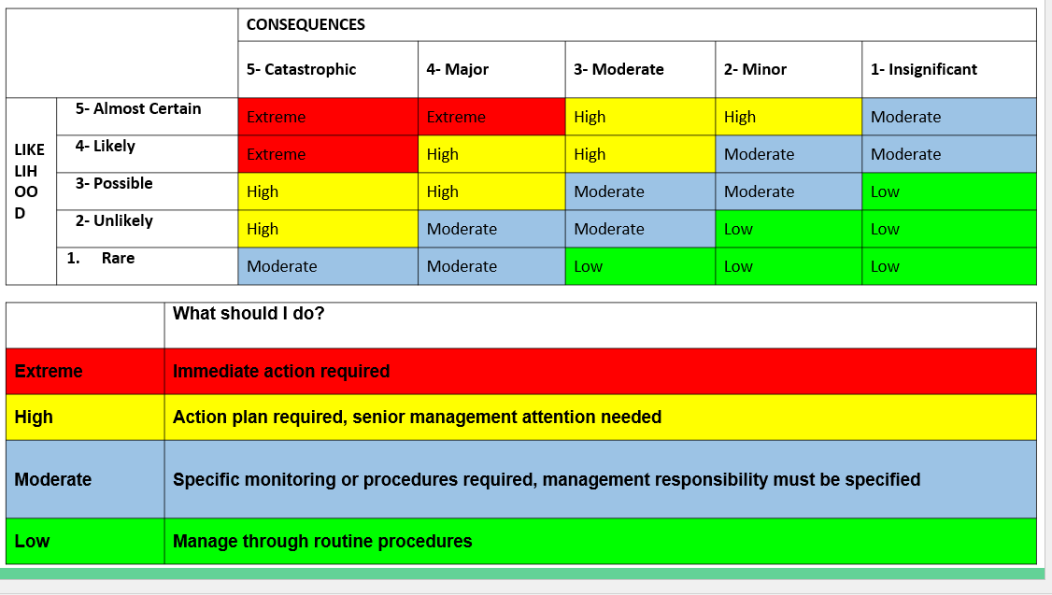

RISK ASSESSMENT: Bunjil Place: 1
Item | What can cause harm? | What could go wrong? | Consequences | Likelihood

Rating | Controls | Completion Date | Person  Responsible | Issues that stop you from fixing or completing the risk assessment

VENUE:
- In a group, work out how will the space be used? Annotate the photos collected from the risk assessment.

- What are the specific unloading, load in/load out, parking, and goods lift information that should be shared with staff, exhibitors, and vendors?

- Does the venue have machinery available to aid with the setup?

- Discuss specific instructions for guests with accessibility issues.
- Inform the venue of anyone attending with special needs.

- Confirm the key points of contact for the planning process and the day of the event

- Are there any keys/passes required to access certain rooms?

FOOD & BEVERAGE:
- Consider and confirm the event food and beverage needs.
- Agree on catering timings and service, will this be appropriate for schools and organisers on the day?

- Confirm final catering numbers and dietary requirements.

- Where can I find out about food allergies and associated medicine eg: EpiPen, Asthma puffer.

- Where can I locate the First Aid kit on the day of the event?
- Are there any learning opportunities to learn how to run back of the house?
TRAIN STATION QUESTIONS:
  - Time of arrival of the first train on the Narre Warren platform before 6:00 pm and immediately after?

  - What is the name of the Narre Warren line to the city?

  - Is it a busy time of day? and what groups of people will be expected to arrive in Narre Warren during that time?

  - Are there any specific rules or regulations that are important when passengers depart and arrive at the station?

  - How many PSO’s (Protective Service Officers) are available in the trains and on the platforms on any given day? Are there more PSO’s present on one day more than another?

RISK ASSESSMENT: Narre Warren
Train Station No: 2
Item | What can cause harm? | What could go wrong? | Consequences | Likelihood

Rating | Controls | Completion Date | Person  Responsible | Issues that stop you from fixing or completing the risk assessment

FOOD COURT QUESTIONS:
- Roughly how many tables are there? Or how many people can you safely seat in the food court?

- How busy is a Monday afternoon in the food court for the public? The area

- Are there any issues you can foresee from observing where you are standing or seated?

- List at least 3 strategies you think can be used to minimise a flood of students accessing the food court during the 4C’s day.

- How are people lined up to collect their orders in the food court?

Food Court No: 3
Item | What can cause harm? | What could go wrong? | Consequences | Likelihood

Rating | Controls | Completion Date | Person  Responsible | Issues that stop you from fixing or completing the risk assessment

BUNJIL PLACE EMERGENCY RESPONSE:

RISK ASSESSMENT: Narre Warren

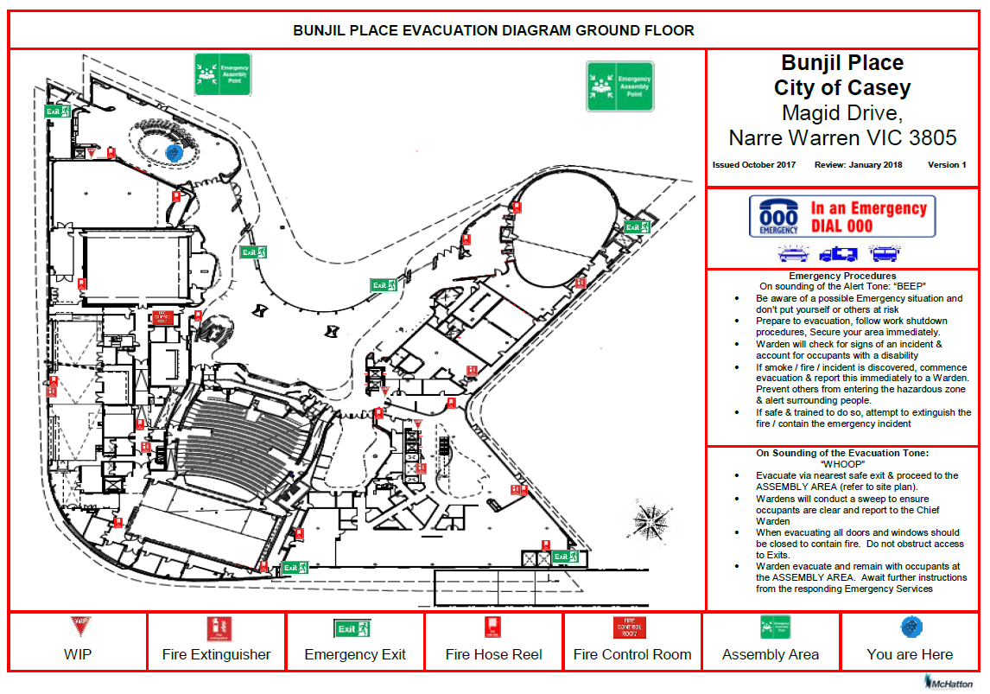
NOTES:

