EVENT MANAGEMENT: BUNJIL PLACE
OHS RISK ASSESSMENT PLAN 2023

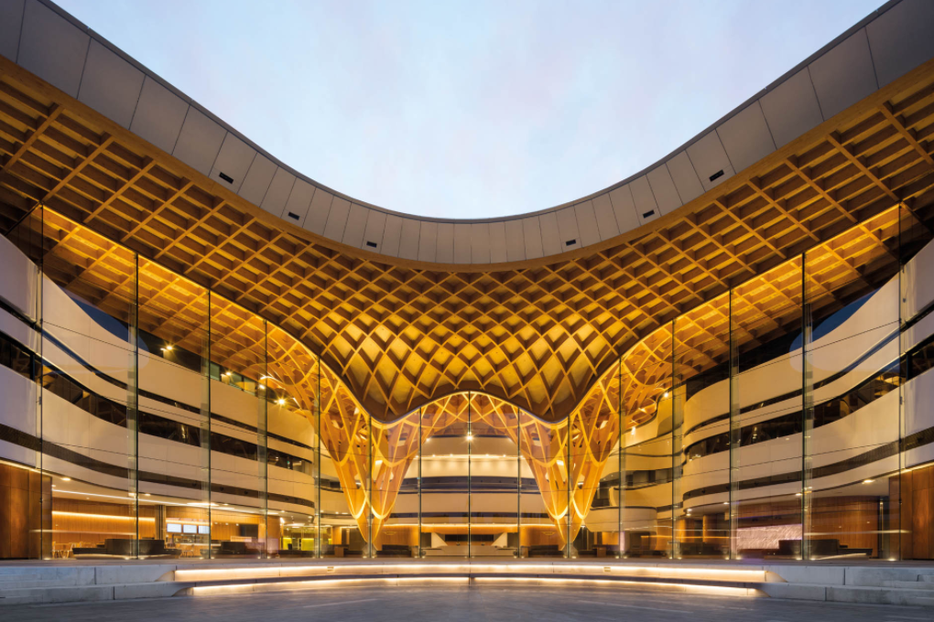
Implementing & Evaluating a Community Project
WHAT TO BRING TO THE BUNJIL PLACE EXCURSION:
□ Create a tick sheet with a list of everything that you and your team must do and information you MUST COLLECT while we are on EXCURSION.
□ Pack your phone & charger to access the pictures taken at the train station, Bunjil Place Library, back of stage, change rooms & the Food court
□ Pack your snacks/money if you have permission to purchase your lunch
□ Bring your laptop! A booklet will be provided for you.
□ You are to work in a team to complete the following OHS/Risk Assessment BUT your written tasks, need to be done individually. Additionally, your group needs to be approved by your teacher.
□ Ask for clarification for this assessment BEFORE you go on the excursion.

TERM 2 - 4 KEY DATES AND TIMES
T2 Week 6  5/6 – 8/6 | Introduction: to 4C’s Showcase
T2 Week 7
11/6 – 15/6
T2 Week 8
19/6 – 22/6
T3 Week 1
10/7- 13/7
T3 Week 2
17/7 – 20/7
T3 Week 3
24/7– 27/7
T3 Week 4
31/7– 3/8
T3 Week 5
7/8 – 10/8
T3 Week 6
14/8 – 17/8
T3 Week 7
21/8– 24/8
T3 Week 8  28/8 – 31/8 | MONDAY  4C’s Performance Night 1 | Input photos and interviews into PP and present to an audience
T3 Week 9  4/9 – 7/9 | MONDAY  4C’s Performance Night 2 | Input photos and interviews into PP and present to an audience
T3 Week 10  11/9 – 14/9 | MONDAY  4C’s Performance Night 3 | Input photos and interviews into PP and present to an audience
T4 Week 1
3/10 – 7/10
T4 Week 2
10/10 – 14/10

OHS RISK ASSESSMENT 2023
Why are we assessing the following areas?
One of the major tasks you need to complete is an OHS RISK ASSESSMENT for the 4C’s event. The places that have been chosen for you to write assessments for are the areas that will be used by our stakeholders and our guests.

1. NARRE WARREN TRAIN STATION: Our families, friends, and guests may need to access public transport on the 5th and 12th of September. We need to ensure that the Station Master is contacted prior to the event to notify them of the event taking place. There may be a large number of people accessing public transport in the evening, prior to the show. There may be a need for extra Protective Service Officers (PSO) from 5 pm till roughly 10:30 pm.
2. BUNJIL PLACE: The event is going to take place on the premises, so becoming familiar with all the spaces, rooms, and areas we will be accessing is vital. Knowing that there will be limited room available at Bunjil Place due to the Archibald exhibition is important. When accessing the spaces make sure you pay attention to how many people can fit in each of the spaces. You will need to assign the school groups rooms and relevant spaces based on the school’s needs and the number of students.
3. NARRE WARREN LIBRARY: This year, for the first time in 16 years, 4C’s is creating a space for students to be able to present their VET items. The main art forms we are going to display are; Fashion & Design, Carvings, and Visual Arts. This space has been opened up to include Community art to inspire our students and for our communities to share their creative abilities.
FOUNTAIN GATE FOOD COURT: The food court is going to be an area that will need to be used by schools to organise their lunch or dinner, before the 4C’s event. Some schools will provide their own meals, others will need to access these spaces. It will be our responsibility to ensure that the schools do not access the Food Court at the same time. How can we ensure that accessing the food court does not become an issue?

BUNJIL PLACE QUESTIONS TO COMPLETE AND RISK ASSESSMENT
- OHS requirements - RISK ASSESSMENT before the event:

- Who are the core teams that will make the event happen? CESC, Bunjil Place, Le Mana, Grace Ministries, Multicultural Police & Library/Museum

- Consider delivery, engagement, and room layout. The map of the event is shown at the end of this bookwork. After going through the entire Bunjil Place building, students have understood how they will engage the students and utilise the room layout/spaces on the day.

- Are there venue maps or links available at Bunjil Place? Venue maps are attached at the end of the booklet and the link venue map below. https://www.bunjilplace.com.au/location

- Take photos of the area for schools and organisers to use – Individual students should have images of Bunjil Place and organise a plan of how they will set up schools in the available spaces.

- Annotate the photos that were taken on the day. Students need to have evidence of the plan to share with their group

Risk Assessment and Risk Management

Just a thought - What needs to be done for your school this term:

- Student permission slips to Bunjil Place (before and after the event)
- Consent forms signed for photos and images to be taken or shared on social media.
- Consent for student work to be published online (Bunjil Place website)

Complete the risk assessment table then each of the questions:

You need to identify a minimum
of 3-5 hazards.

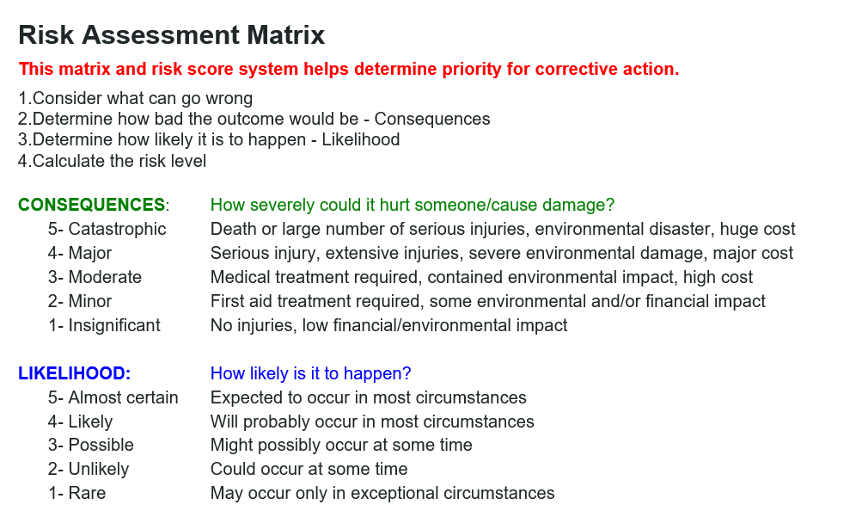

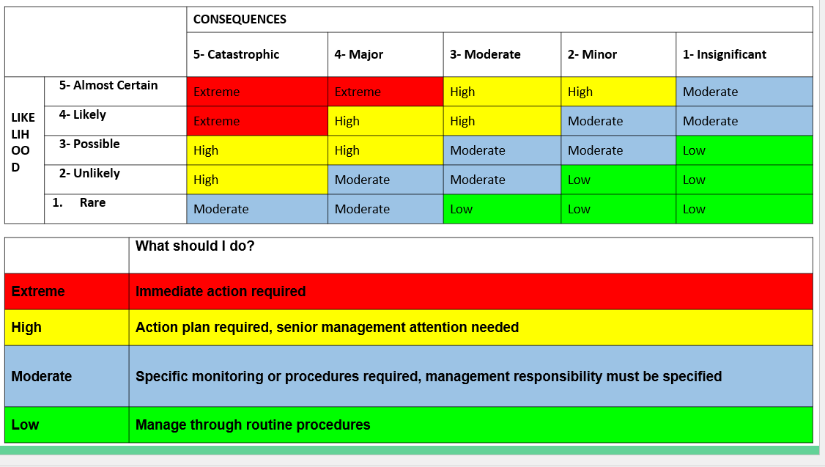

RISK ASSESSMENT: Bunjil Place: 1
Item | What can cause harm? | What could go wrong? | Consequences | Likelihood

Rating | Controls | Completion Date | Person  Responsible | Issues that stop you from fixing or completing the risk assessment

VENUE:
- In a group, work out how will the space be used? Annotate the photos collected from the risk assessment – Now that individual students have completed the plan, they should have something to contribute when working in their team.

- What are the specific unloading, load in/load out, parking, and goods lift information that should be shared with staff, exhibitors, and vendors? Students should have images of this and/or should have asked about this area. However, this will not be needed for use on the day because we will not require heavy machinery.

- Does the venue have machinery available to aid with the setup? Yes. Bunjil Place has its own machinery that is kept onsite but the operator MUST have a license to operate these machines due to possible dangers, risks, and OH&S issues.

- Discuss specific instructions for guests with accessibility issues. All special needs visitors that require wheelchair access, will have lifts and areas in the venue assigned for easy access for the attendee and their carer/aide.

- Inform the venue of anyone attending with special needs. As far as we know, we do not have any guests that will require access to this space until our tickets are made available at the end of July.

- Confirm the key points of contact for the planning process and the day of the event. Prior to and during the event, Ms. Tia & CESC teachers will be available to guide & assist with the planning process. The stakeholders specifically Bunjil Place staff and Le Mana will be available to support on the performance nights.

- Are there any keys/passes required to access certain rooms? Yes, but there may only be two available on the day. One will be left with Ms. Tia, the other will be to a person who will actively be moving around Bunjil Place during the preparation and during the night.

FOOD & BEVERAGE:
- Consider and confirm the event food and beverage needs.
What will be advertised for students to do for snacks and lunch. Think about the cost when planning to purchase food from the Bunjil Place café or from the Food Court. What are the school policies relating to accessing this space?

- Confirm final catering numbers and dietary requirements. There is an agreement made that any food vans selling food on the night need to make more than $1000 to be worth their time and resources.

- Where can I find out about food allergies and associated medicine eg: EpiPen, Asthma puffer. When planning a menu, the chefs will have a selection of basic foods that can address some food allergies and intolerances such as lactose-free drinks, gluten-free bread, remove nuts, eggs, and yeast. Any basic first aid kits will be held by one of your teachers and anything else can be found in Bunjil Place including a Defibrillator.

- Where can I locate the First Aid kit on the day of the event? There will be two kits that will be held with your teachers on the day. Anything additional can be found at the Bunjil Place reception desk. Are there any learning opportunities to learn how to run back of the house? There are programs available every year based on the needs or requests of the Community.

TRAIN STATION QUESTIONS:
  - Time of arrival of the first train on the Narre Warren platform before 6:00 pm and immediately after? 5:51 pm but to allow for time, there is a train that will arrive at 5:32 pm. The trains that will arrive 6:08 pm and the time after that is 6:12 pm.

  - What is the name of the Narre Warren line to the city? Flinders

  - Is it a busy time of day? and what groups of people will be expected to arrive in Narre Warren during that time? The time from 5pm – 7pm is considered peak hour traffic. The group that sources the train at this time are employees travelling from the city to the Southeast, College and University students.

  - Are there any specific rules or regulations that are important when passengers depart and arrive at the station? The main safety issue at the train station and where accidents generally happen, is the failure of people to stay behind the yellow line.

  - How many PSO’s (Protective Service Officers) are available in the trains and on the platforms on any given day? Are there more PSO’s present on one day more than another? The number of PSO’s varies based on the need of the station/area. They generally work from the afternoon till late in the evening/night depending on whether or not there are special events on. 4C’s would be one of those events where notification will be required.

RISK ASSESSMENT: Narre Warren
Train Station No: 2
Item | What can cause harm? | What could go wrong? | Consequences | Likelihood

Rating | Controls | Completion Date | Person  Responsible | Issues that stop you from fixing or completing the risk assessment

FOOD COURT QUESTIONS:
- Roughly how many tables are there? Or how many people can you safely seat in the food court during lunchtime?

- How busy is a Monday afternoon in the food court for the public?

- Are there any issues you can foresee from observing where you are standing or seated?

- List at least 3 strategies you think can be used to minimise a flood of students accessing the food court during the 4C’s day.
    - Schools or students can bring/provide their own lunches.
    - Organise timeframes for schools to access the food court.
    - Ask Bunjil to provide food on the premises at student prices.

- How are people lined up to collect their orders in the food court? Areas near the table can bank up due to the lunch crowds. People will not always leave room for other customers trying to walk through the food court area. It is crucial that people are aware of these issues and find ways to accommodate the needs of people in the area.

Food Court No: 3
Item | What can cause harm? | What could go wrong? | Consequences | Likelihood

Rating | Controls | Completion Date | Person  Responsible | Issues that stop you from fixing or completing the risk assessment

BUNJIL PLACE EMERGENCY RESPONSE:

RISK ASSESSMENT: Narre Warren

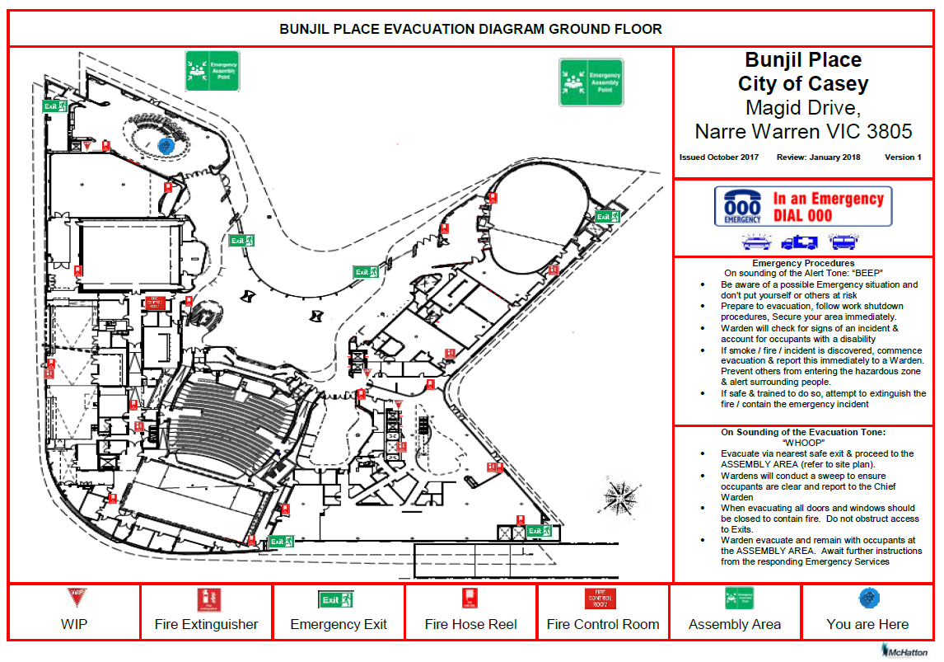
NOTES:

